**Graph Implementation in c++**

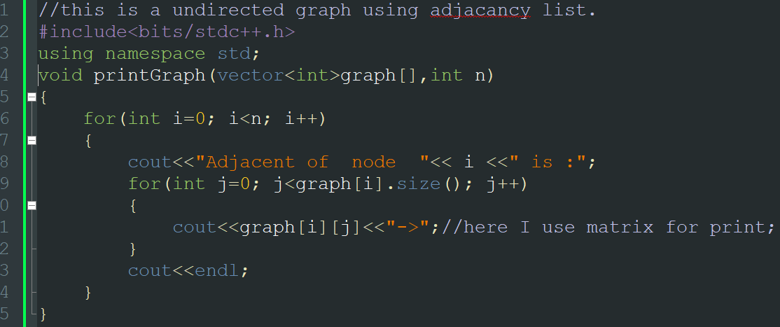

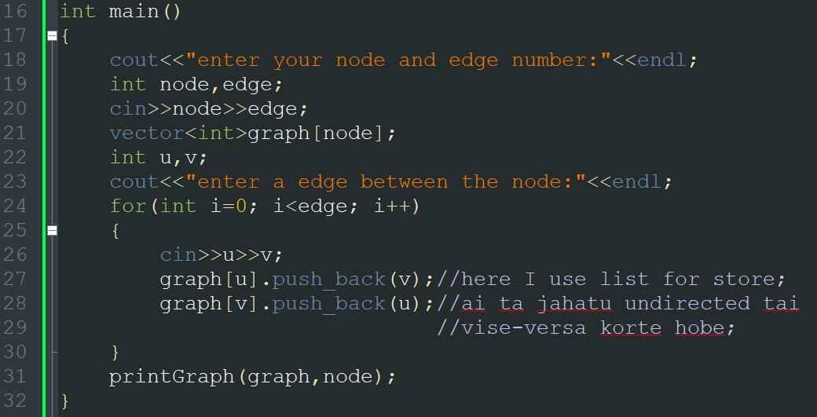 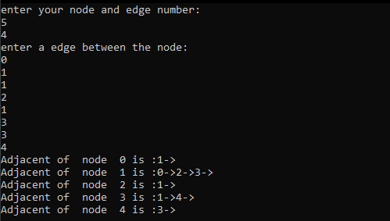

**(bfs)**

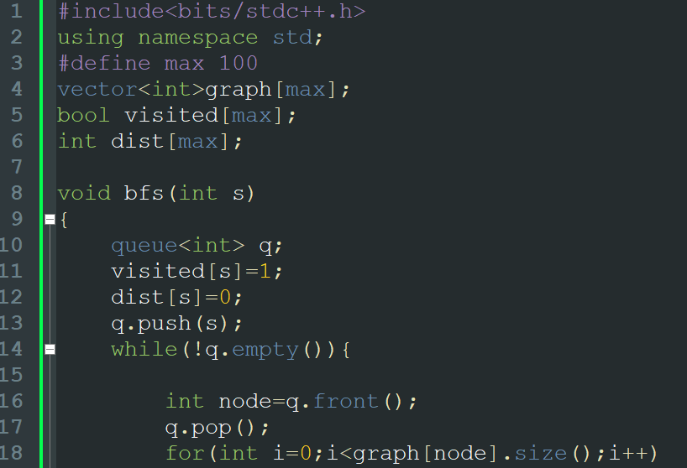

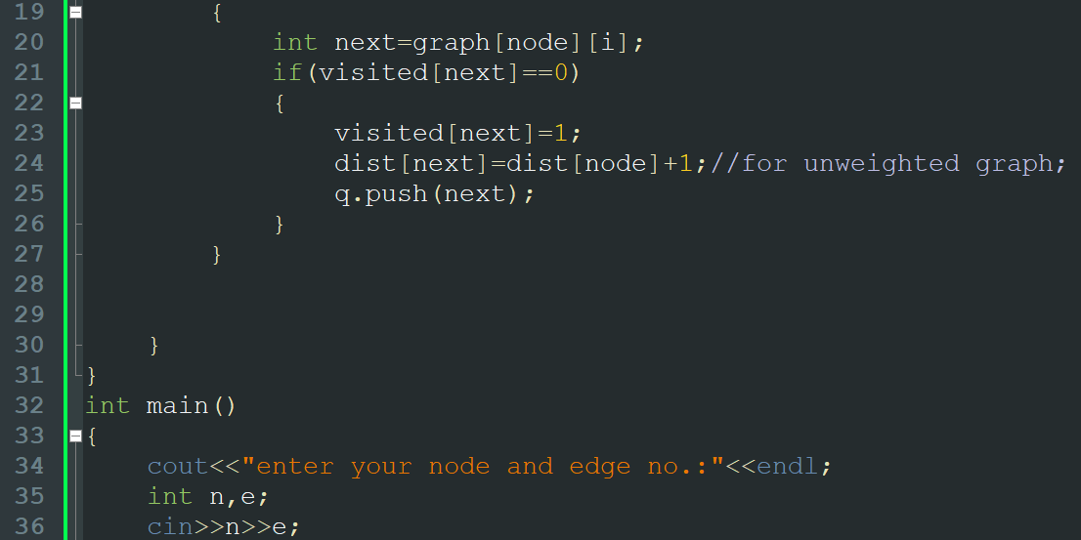

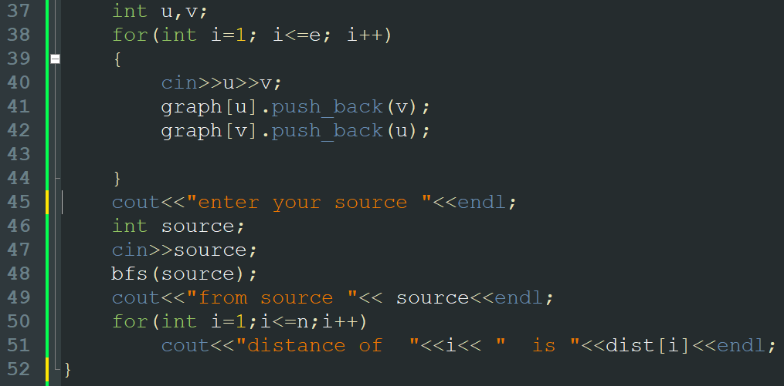

**Output:**

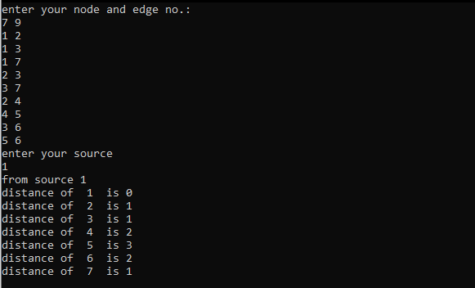

**(dfs)**

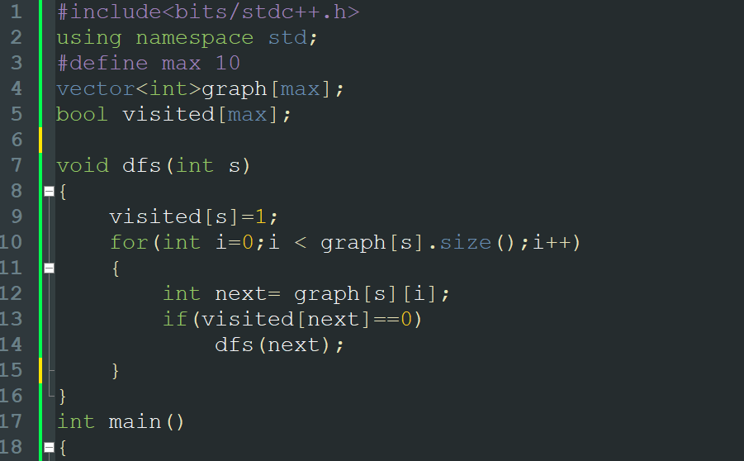

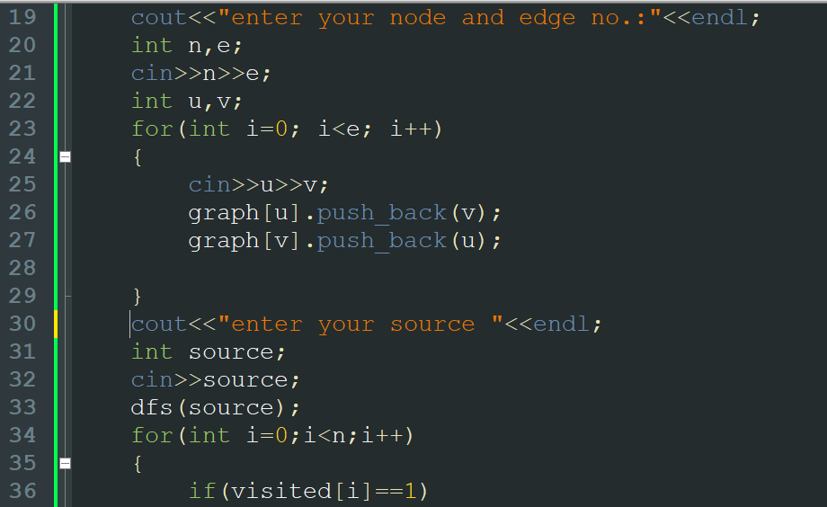

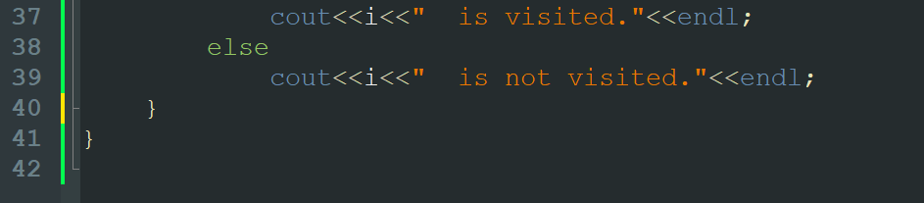

**Output:**

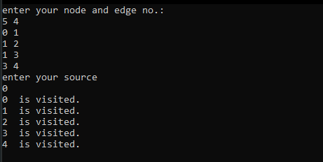

***DisjointsetUnion:***

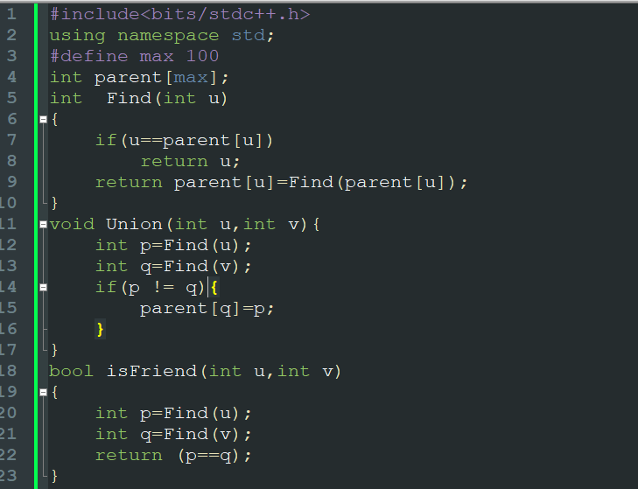

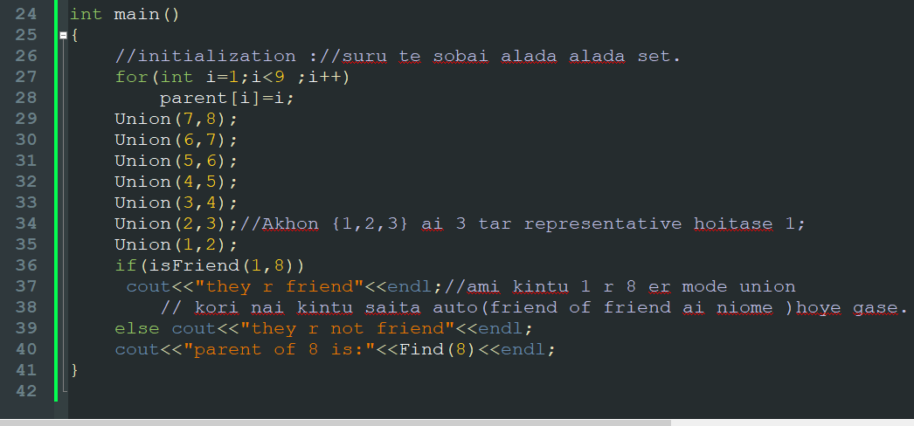

**Output:**

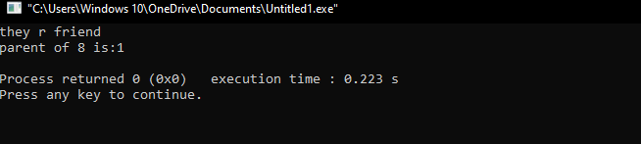

**\*disjoint set union er 2 ta part ase:**

**1) Find: Find er kaj parent of set /set representative khuje bar kora;**

**2) Union: Union er kaj 2 ta disjoint set jog kore 1 ta set kora.**

**Greedy Method**

Greedy mane lobe. Orthat , kono kisu na dakhe jar man kom ba basi take sobsomoy basai kora.

**Fractional knapsack:**

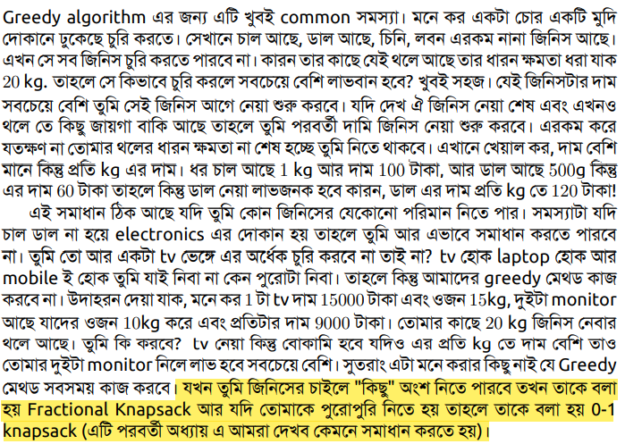

**Problem-14 -Fractional Knapsack problem: Given items t1: t2 , ...,tn (items we might want to carry in our backpack) with associated weights s1; s2 , ... , sn and benefit values vx , v2 , …, vn , how can we maximize the total benefit considering that we are subject to an absolute weight limit C?**

**Solution:**

Algorithm: 1) Compute value per size density for each item,d=v/s.(d=density, v=value & s=size)

2) Sort each item by its value density.

3) Take as much as possible of the density item not already in the bag.

Time Complexity: O(nlogn) for sorting and O(n) for greedy selections.

Note: The items can be entered into a priority queue and retrieved one by one until either the bag is full or all items have been selected. This actually has a better runtime of O(n + clogn) where c is the number of items that actually get selected in the solution. There is a savings in runtime if c = O(n), but otherwise there is no change in the complexity.

* I always use below system using priority queue:

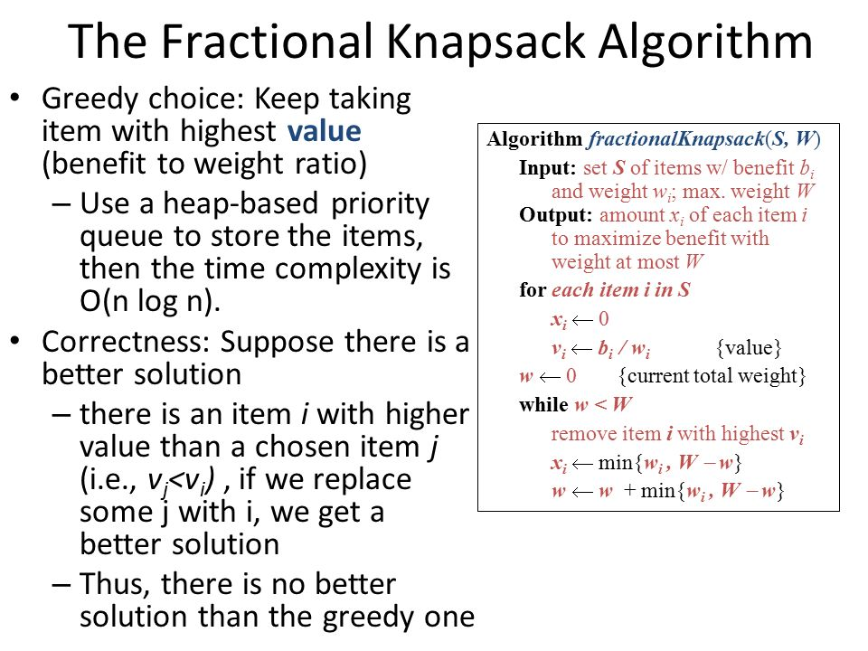

**Minimum Spanning Tree**

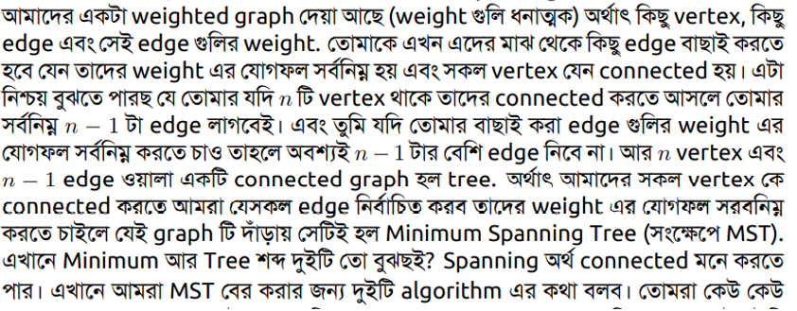2 ta MST ase:

1. kruskal's algorithm(edge based): Ai algorithm er kaj hose jai jai edge er man coto sagulo kromanne (asending order) naoya but:-

* Sobgulo node connected hote hove.

* edge nite hobe node sogkha thike 1 kom.

* & kono cycle thakte parve na.

(See amimation from online if untill I don't understand.

Here is psudocode:

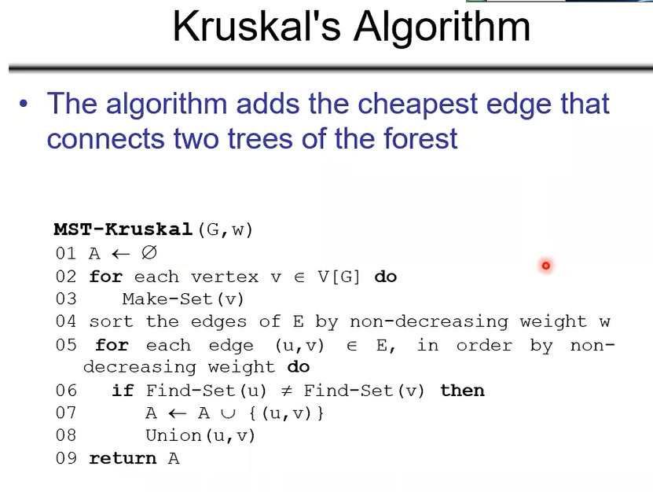

complexity:O(VE).

1. prim's algorithm(vertax based): Ai algorithm er kaj holo ami jakono vertax ke sourch dore suru korbo.Sourch theke jai adjacent gula bar holo tader mode sobcaite kom cost a kontate jaoya jai. Then,amr kase thakne 2 ta node(sourch & jaitate akhon aslam).Akhon ai 2 ta node theke jai adjacent node gula bar holo tader mode sobcaite kom cost a kontate jaoya jai.Ai babe colve (vertex number-1) porjonto.R kono cycle hoya jaivo na.Pasapasi sobgula node connected korte hove.

(See amimation from online if untill I don't understand.)

Here is psudocode:

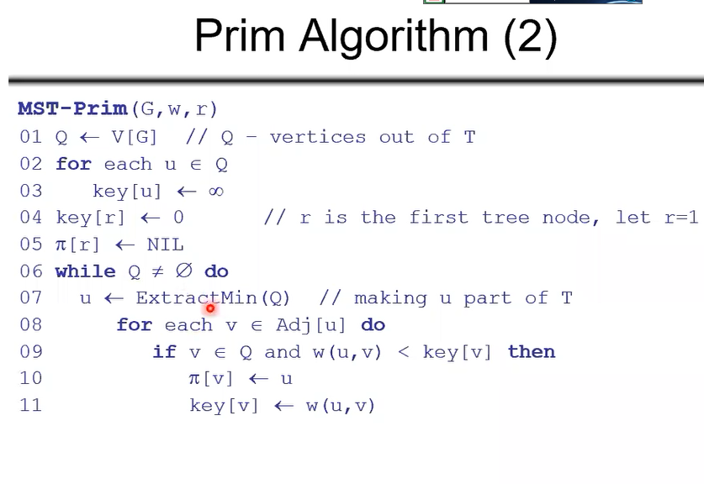

complexity:O(ElgV). //using heap.

**gcd & lcm-mane gosagu & losagu.**

**Applicaton:**

**a) gcd:**

**1) greatest/largest/maximum.**

**2) divided something in equal.**

**b) lcm:**

**1) smallest/minimum;**

**2) repeated over and over;**

**3) when both will meet again;**

**4) when both will be equal;**

**A list of problem of gcd & lcm:**

**1. At the gym, Hillary swims every 6 days, runs every 4 days and cycles every 16 days. If she did all three activities today, in how many days will she do all three activities again on the same day?**

**2. Oscar needs to ship 14 rock CDs, 12 classical CDs, and 8 pop CDs. He can pack only one type of CD in each box and he must pack the same number of CDs in each box. What is the greatest number of CDs Oscar can pack in each box?**

**3. I want to plant 45 sunflower plants, 81 corn plants and 63 tomato plants in my garden. If I put the same number of plants in each row and each row has only one type of plant, what is the greatest number of plants I can put in one row?**

**4. Cups are sold 6 to a package and plates are sold 8 to a package. If you want to have the same number of each item for a party, what is the least number of packages of each you need to buy?**

**5. A full moon occurs every 30 days. If the last full moon occurred on a Friday, how many days will pass before a full moon occurs again on a Friday?**